Requirement and User Interface Document

Contents

I. Introduction: 3

A. Business Problem 3

B. Solution Overview 3

C. Proactive and Anticipated needs 3

D. Potential market for point of customers 3

E. Glossary of terms referred in document 4

II. Process Flow Steps 4

III. New Registration 5

A. Registration Sign up 5

B. Account Verification via OTP 6

C. Sign in 6

IV. Account Home Page 7

A. My Profile 7

1. My Profile Flow Chart 7

2. Functionality inside My Profile: 7

3. Views in My Profile 8

a) Add New Business 8

b) My Info 8

c) My Business Plan 8

B. Invoice 11

1. Invoice Flow Chart 11

2. Functionality 11

3. Views 11

a) View 1: Default view 12

b) View 2: Customer number not available 12

c) View 3: Customer number is available 12

C. Payables 13

D. Receivables 14

E. Sales Dashboard 15

F. Raise ticket 16

I. Introduction:

The landscape of retail business is huge in our country. Every day the foot print of different business continues to grow as the economy scales up to meet consumer demands. Larger companies are able to drive their business by making powerful decisions based on data. Because numbers speak the tale, most business smaller than these huge corporations have a less competitive edge as they are not utilizing data to help grow their business. MYDATA focuses on this specific aspect to help fill the void.

A. Business Problem

* Low level to mid-level size companies are not capturing customer data. A lot of manual work is involved in managing inventory, payables, receivables. The following are the common challenges that these organizations face.
* Unable to define valuable customer base.
* Unable to track trends and identify purchase patterns.
* Unable to forecast supply by connecting customer related specific products that are high in demand.
* Access to digital marketing.
* Business predictability and Profit and Loss analysis.

B. Solution Overview

MYDATA will provide solution to small scale business owners and give them an advantage over the following aspects.

* Capturing customer data and hence prioritizing valued customers.
* Prioritize payables and receivables.
* Track profit and loss.
* Ability to analyses their data that can help make decisions to improve their business.
* Automate digital marketing via bulk SMS, Email blasting and IVRS.

C. Proactive and Anticipated needs

Organizations are increasingly under competitive pressure to not only acquire customers but also understand their needs to be able to optimize customer experience and develop long standing relationships. By sharing their data…relaxed privacy in its use, customers expect companies to know them. This will also help form relevant interactions and provide a seamless experience across all touch points.

D. Potential market for point of customers

|  |  |
| --- | --- |
| * Furniture and Electronics shops | * Lodges |
| * Paint | * Bakery and sweet shops |
| * Cement and Iron shops | * Chicken stalls |
| * Gift shops | * Fertilizer shops |
| * Book stores | * Vegetable shops |
| * Institute and training centers | * Flower decorations |
| * Hostels | * Catering Services |
| * Garment shops | * Travel agency |
| * Grocery stores | * Real estate |
| * Banquet hall |  |

E. Glossary of terms referred in document

|  |  |
| --- | --- |
| Term | Definition |
| Business Establishment (BE) | This is a commercial retail location of business open to public. |
|  |  |
| Business Owner (BO)/ Single Business Owner (SBO) | Is the one who owns or manages a business establishment and provides goods and services to public. This can also be the manager or person in charge who primarily interacts with the customer. |
| Multiple Business Owner (MBO) | Is the business owner who owns multiple business establishments of either same type or business or different type of business |
|  |  |
| Business Vendors (BV) | Are the people who provide inventory and other commercial services to the business establishment. |
|  |  |
| End Customers (EC) | Are the consumers who purchase goods and services from the business establishment owned by the business owner |

II. Process Flow Steps

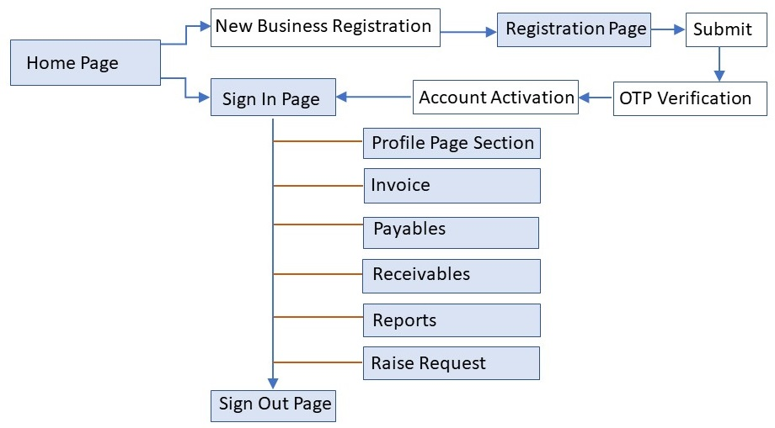Below is the End to End Business process flow at a glance. The home page below refers to the SMYDATA home page from where the BO is able to login to their account. In some cases, home page can also be the main page of the BE’s own website from where the BO can login and is redirected to their respective SMYDATA account.

III. New Registration

A. Registration Sign up

This is the first step in the BO sign up process. BO comes up to this page using the SIGN UP / REGISTER button located on the SMYDATA home page. A BO enters details shown as per the form and clicks SUBMIT.

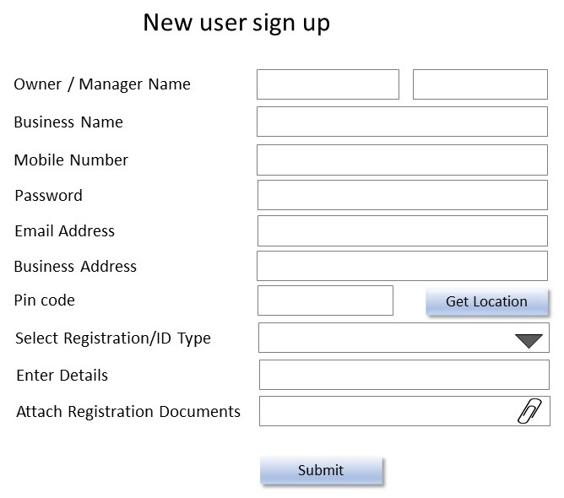

Business Details:

* **Company Name** is the name of the registered BE.
* **Owner / Manager name** is the primary BO.
* **Mobile number** is the primary contact number used for account authentication and verification.
* **Password** is set up by BO as per their preference.
* **Email address** is optional
* **Business address** is the full mailing address and includes door number, street name, township, city district along with pin code
* **Website** is the details of any available websites and URL address existing for the business.
* **Business Category** is a drop-down feature where the BO can select from one of the following categories based on their type of business. Click here for the list.
* **Registration Information** is where the BO will enter the required details from valid form of registration documents. This is a drop-down category which will include Labor ID, PAN, TIN, Aadhar. BO will select one category and enter the details in the next field called ‘Enter Details’.
* **Business Logo and Photos** is where the BO can upload their BE Logo and photos that they wish to portray to public.

**Note:**

* All fields are mandatory except **EMAIL ADDRESS** which is made optional.
* **Mobile number**: Logic retroactively checks for existing registered phone numbers in the form of predictive query and invalidate the entry based on existing ones.
* **Password**: Set up password logic as per recommended combination standards (letters, numbers, special character etc.)
* **SUBMIT**: Button generates an OTP sent as text message to the mobile number that BO entered on the sign-up form.

B. Account Verification via OTP

BO enters the OTP received on the mobile device and clicks **SUBMIT.**

**Note:** Once user clicks on SUBMIT and if OTP verification is successful the data is captured and a unique id is generated in the back end. An email notification is automatically sent to the backend team.

If the BO did not receive the code or if it was invalid/expired, the code can be requested using the resend option.

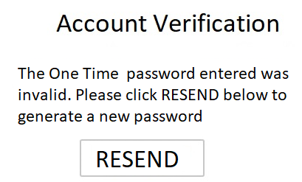

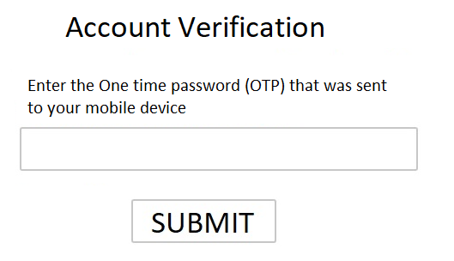

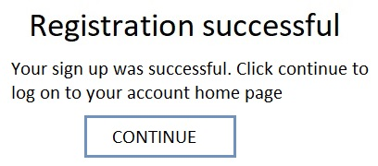

C. Sign in

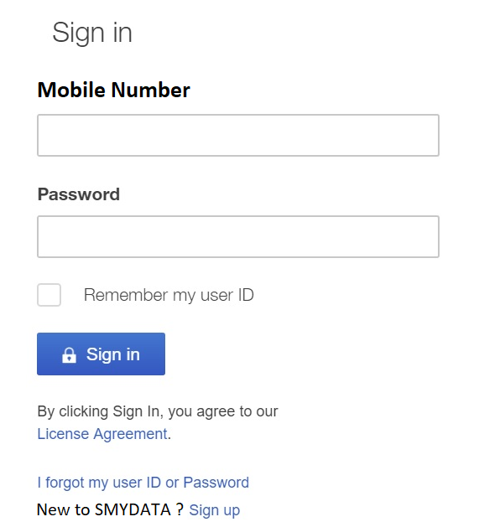Following successful registration notification, the BO can login to their account using the mobile number and password they used during sign up process.

Description of fields:

**Mobile Number**: Registered mobile number of BO

**Password:** The set password that was established during sign up process.

**Remember my ID:** This feature will save the user id from the trusted system it is being used requiring the user to simply enter the password for logging in the account.

**Forgot my password:** In cases where a BO forgets or is unable to login, they can use this link to request an OTP sent to their registered mobile number. Once OTP is entered the BO can set a new password.

IV. Account Home Page

A. My Profile

1. My Profile Flow Chart

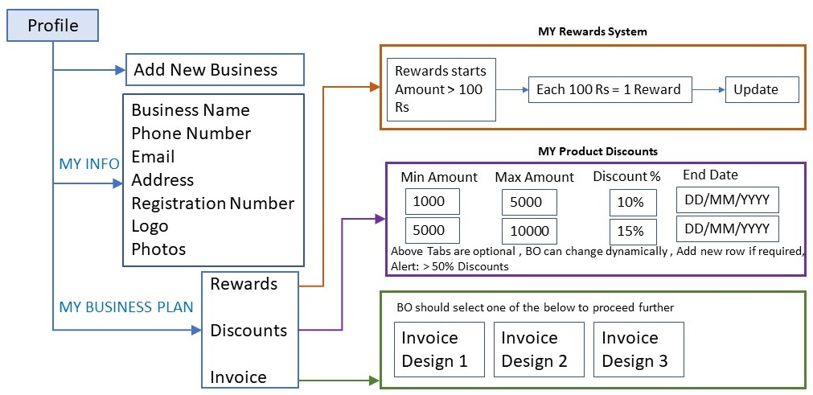

2. Functionality inside My Profile:

Here in this section the BO can update their information regarding business and is also able to dynamically customize the logic behind rewards points in an easy to use interface. My Profile section consists of 3 sections called ADD NEW BUSINESS, MY INFO and MY BUSINESS PLAN. The functionality serves both SBO and MBO.

In case of a SBO, upon logon they can directly view their account page related to their BE.

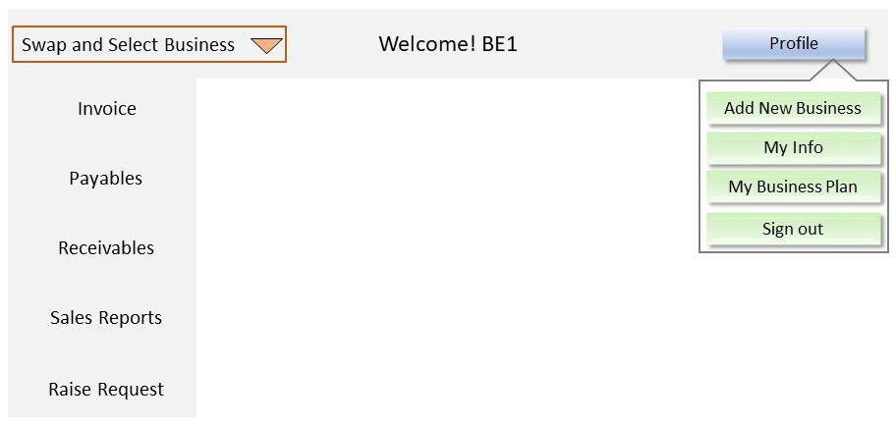In case of MBO, upon logon the BO should select one business from the dropdown list. This enables access to the specific related information. This dropdown will exist as default in all the pages in INVOICE, PAYABLES, RECEIVABLES, SALES DASHBOARDS, RAISE REQUEST. At any point, it will allow the BO to switch and view data as required.

**Note:** The dropdown will appear only if the BO has registered more than one business. The process to add business is explained in the next section.

The image shows the default view of account homepage under a MBO logon scenario.

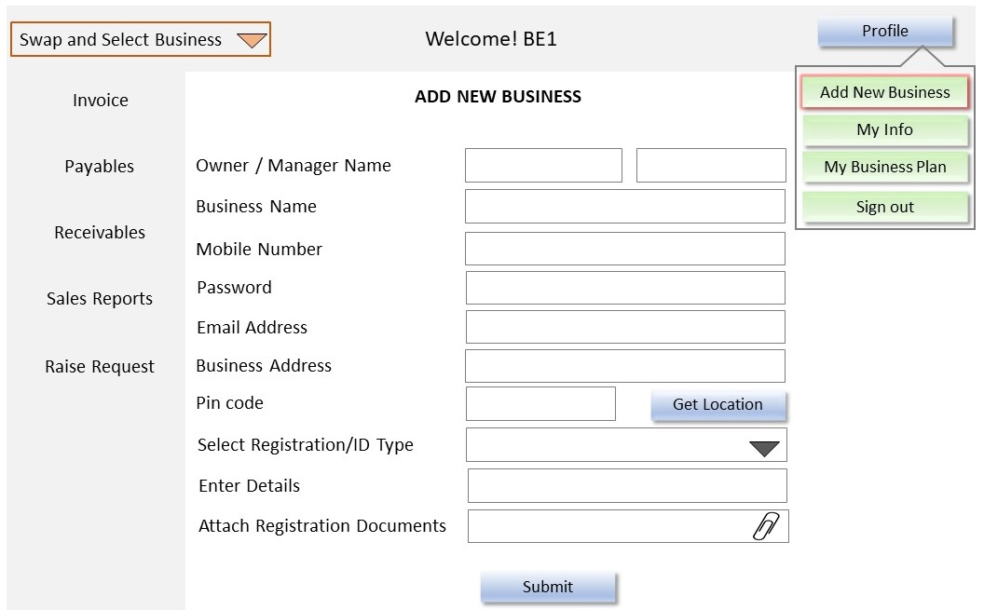3. Views in My Profile

a) Add New Business

* BO can add multiple businesses after initial login, under MY PROFILE and then by selecting ADD NEW BUSINESS.
* BO will need to fill in the details as required on the form and click SUBMIT.
* Upon clicking SUBMIT and OTP will be generated to the registered mobile.
* BO needs to enter the OTP to activate New Business under one single account.

**Note:** Based on business category, after login the UI and functionality will change.

b) My Info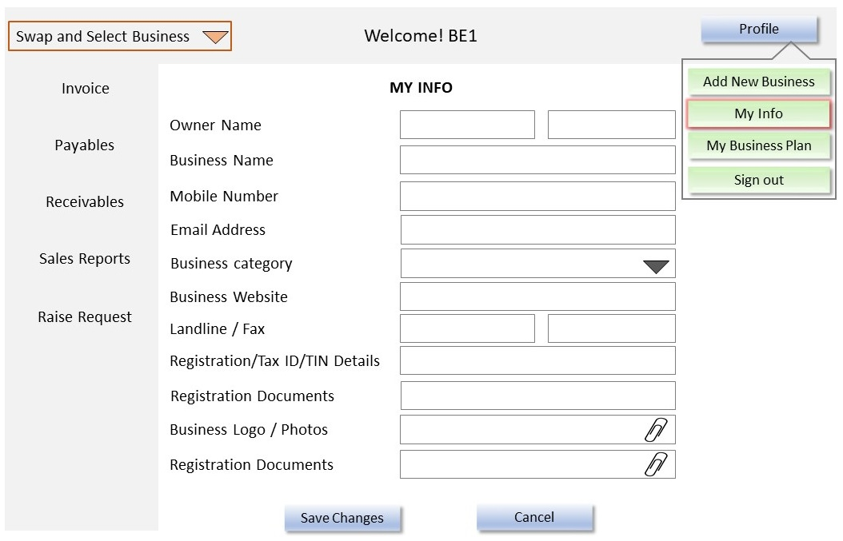

* A SBO should be able to modify or update the business information and upload photos specific to their BE.
* A MBO will additionally be able to switch between their registered BE’s and update the business information as needed.
* The image shows the view when clicked on **My Info** under **Profile**.
* It contains fields where in BO can enter and update their profile information
* They can also upload photos, document and update as needed.
* They can update the registration documents by uploading in case they are near expiration.
* Once done they can save by clicking **Save Changes**.

c) My Business Plan

Under this view, A SBO or MBO will have the capability to set their rewards and discounts and pick invoice design templates. This consists of 3 views.

* My Product Discounts
* My Rewards System
* Invoice Design Samples

**My Product Discounts:**

* BO can make discounts optional to their business and can change /add/disable new discounts dynamically.
* BO is able to set minimum amount, maximum amount and percentage of discounts. A BO can add multiple discounts by clicking on **Add New**. Based on customer invoice, the discounts get applied. A BO can set end date to the discounts.

**My Rewards System:**

* BO can make rewards optional to business and they can change/add/disable new rewards dynamically.
* BO can set amount if customer invoice is greater than set rewards, then customer will be eligible for the rewards.
* Reward Amount: Here the value of points against cash value is defined by BO
* Fixed 1 Reward: This will be fixed to 1 Reward.
* End Date: SBO can set End Date to rewards. From that date rewards rewards will not be given on purchase. Note: Redemption of rewards date is different.
* Additionally, MBO can reuse existing rewards system of one business to other different businesses.
* With an option of Apply to: from dropdown, they can select multiple businesses and apply. So same rewards can be applied to selected business.
* Here the BO can add new discounts based on their requirement that they can offer to EC.
* Both the Amount and Discount % are free form fields.
* The logic works in the manner if for example the purchase amount is more than 20000 then automatically a 5% discount is applied to the Invoice.
* The screen also contains enable/disable switch where in the BO can activate or deactivate a specific discount offering
* Likewise, the BO can also add new discounts by using the Add New button.
* Sign up bonus rewards can be used to give points to a new customer.
* Reward points bonus range can be used to define a purchase amount price range to give bonus points for more loyal customers.

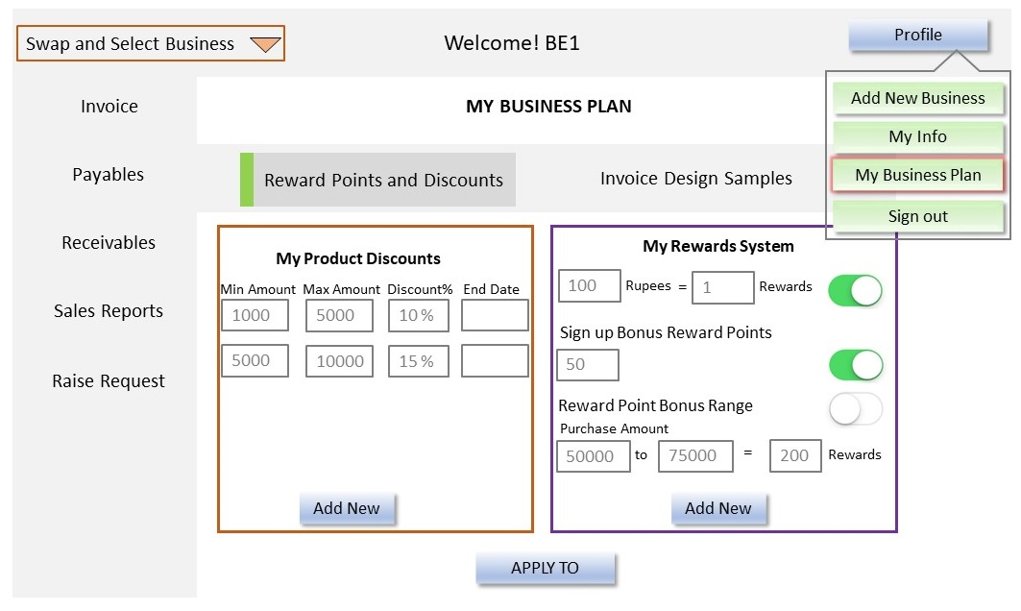

**Invoice Design Samples:**

* SBO has to select mandatory one type of invoice out of three.
* 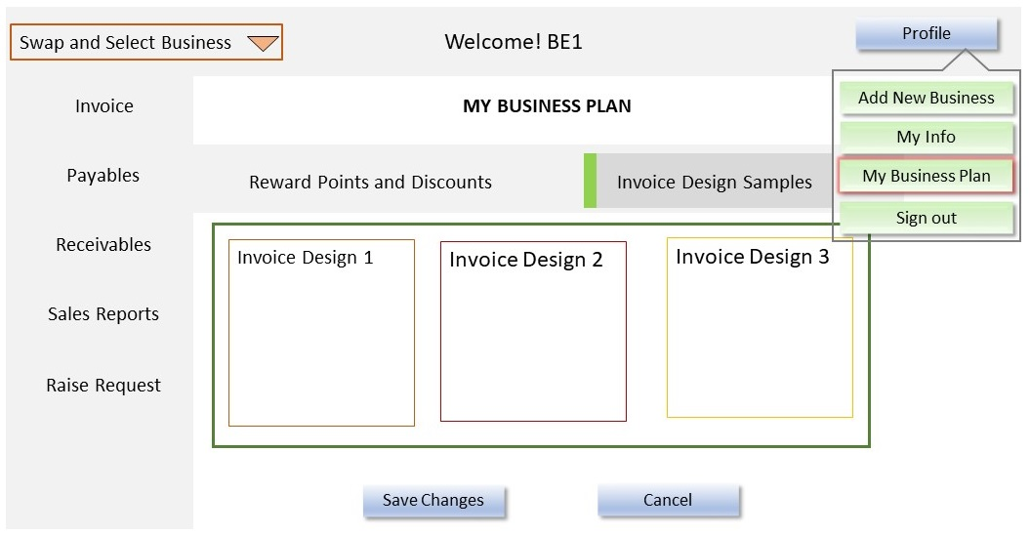The selected invoice will be displayed in Invoice as per GST page.
* Note: MBO can select different invoice designs to their different businesses.
* This view contains 3 preset design templates.
* BO can select one and save by using the Save Changes button.
* When BO attempts to generate an invoice from the Invoice Tab, the invoice is printed with the design layout that was selected from here.

B. Invoice

1. Invoice Flow Chart

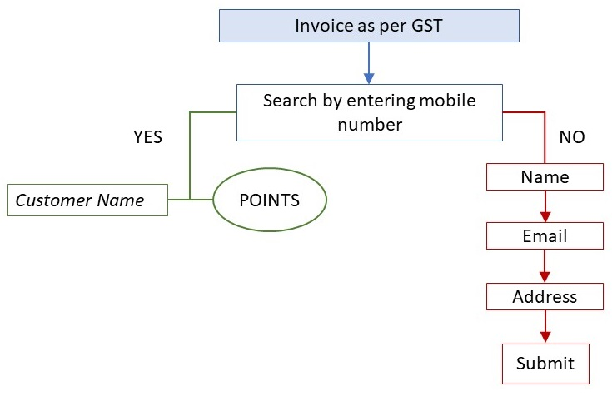

2. Functionality

The important driving factor in this section would be the customer phone number that ties all the records and transactions to it. Using this screen, a BO can:

* Look up points based on phone number
* Generate purchase invoices
* Register a new EC.
* View or redeem points for the EC.

3. Views

There are 3 different views that BO will interact with depending on the requirement.

a) View 1: Default view

b) View 2: Customer number not available

c) View 3: Customer number is available

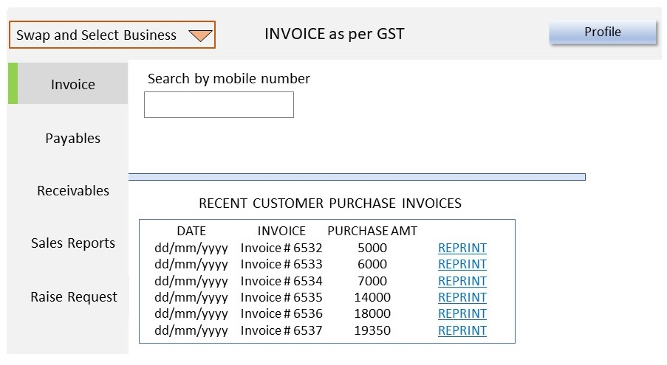a) View 1: Default view

* This is the default view when BO comes to the Invoice tab.
* A BO can search for EC by entering their phone number in **Search by mobile number field**.
* The page dynamically creates fields based on search result.
* Also in this view most recent transactions made in the current day are displayed.
* The latest transaction is showed on top followed by the rest.
* The BO can view for quick reference and reprint the invoice if necessary.

b) View 2: Customer number not available

* 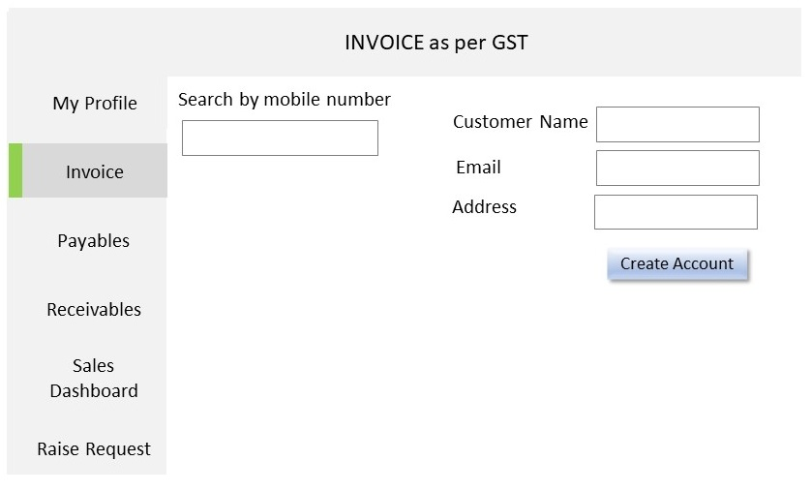BO enters customer number in and customer is not found.
* This automatically creates 3 fields **Name**, **Email** and **Address.**
* This implies that the customer data is not already in the system and creates an opportunity for the BO to track this customer specific data going forward.
* The EC provides the details such as their **Name**, **Email** and **Address**.
* BO enters the details and clicks on **Create Account**.
* This creates an account linked to this EC’s mobile number and can be used for future transactions.

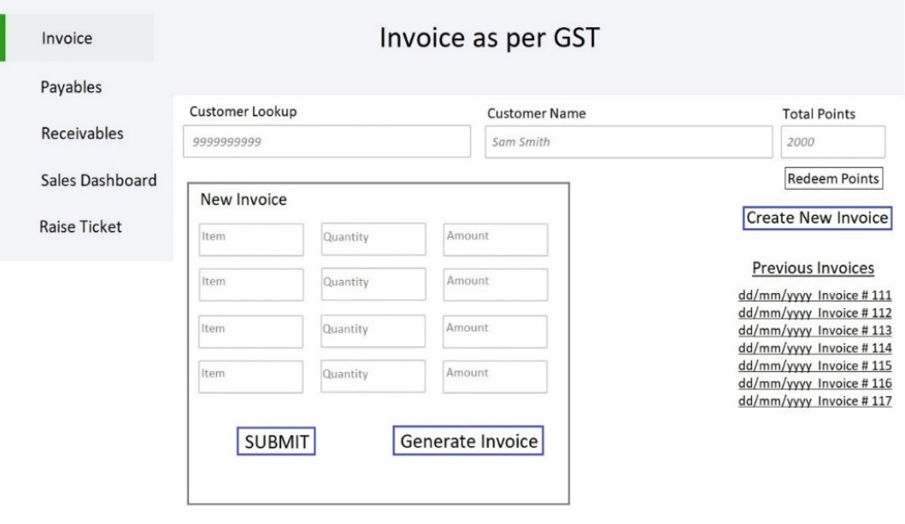c) View 3: Customer number is available

* BO enters the mobile number of EC.
* The view shows available points for EC along with the option to redeem.
* It also displays recent invoices associated with the specific EC
* BO can generate invoices for the purchase transactions
* While in an active invoice The BO can redeem points for EC, which will reduce the total amount based on the logic of points converting to currency.

C. Payables

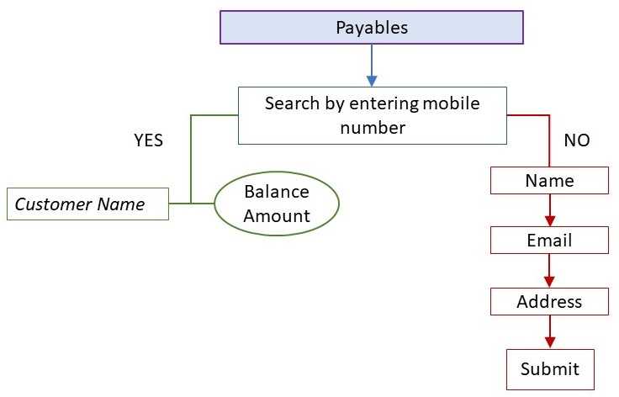

D. Receivables

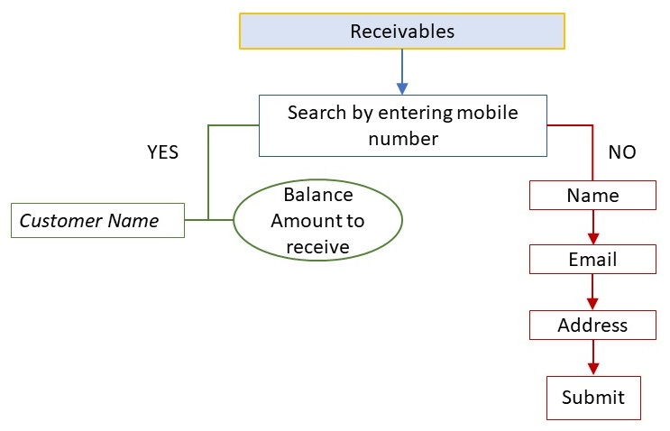

E. Sales Dashboard

F. Raise ticket

This is the last section in the account home page. The BO uses this page to raise a request with the SMYDATA service team. This is used by BO to send IVRS or email blast to the customers regarding promotions.

